Up-to-date regional gravity and aeromagnetic data to unravel the geological patterns of the pre-Mesozoic substratum of the Paris Basin
J. BAPTISTE ^{1,2,3}*– j.baptiste@brgm.fr ; G.MARTELET ^{1,3} – g.martelet@brgm.fr ; M. FAURE ^{1,2} – michel.faure@univ-orleans.fr ; L. BECCALETTO ³ – l.beccaletto@brgm.fr ; J. PERRIN ³ – j.perrin@brgm.fr;

1 : UMR 7327 - CNRS/BRGM/Université d'Orléans
2 : Institut des Sciences de la Terre (ISTO)
1A, rue de la Férollerie
45071 Orléans Cedex 2- France
3 : Bureau de recherches géologiques et minières (BRGM)
3, avenue Cl. Guillemin, BP 36009, 45060 Orléans Cedex 2 - France

*: corresponding author
The Paris Basin is an intracratonic basin made of Meso-Cenozoic sediments unconformably overlying the Variscan substratum. The Pre-Mesozoic substratum of the Paris Basin constitutes an important segment of the Variscan belt in Western Europe. It crops out around the Paris Basin in four massifs, namely the Massif Armoricain, Massif Central, Vosges, and Ardennes, in the West, South, East, and Northeast of the basin, respectively. Although these massifs are rather geologically well characterized, their lithological and structural extensions below the Paris Basin are poorly known. Consequently, the structural relationships, and the geological framework of this hidden part of the Variscan belt are still in debate.
Compilation, processing, and interpretation of new high resolution aeromagnetic surveys combined with up-to-date gravity data covering a large southern half of the Paris Basin provide an unprecedented insight into the buried pre-Mesozoic substratum. Our geophysical interpretations support that the pre-Mesozoic substratum is separated into two western and eastern structural domains, by the N-S striking Paris Basin Magnetic Anomaly (PBMA; fig. 1).
The general interpretative sketch is provided in Figure 1. Among the noticeable features we propose a new extension of the Saxo-Thuringian and Armorican domains in the eastern part of the Paris Basin, north of the Vosges. These domains are separated by a N150-160° discontinuity located in the central part of the Paris Basin near and superimposed on the PBMA, and in the northeast by the NE-SW Bray-Vittel dextral fault.
West of the PBMA, regional N150-160E aeromagnetic and gravity discontinuities gradually straiten the Central Armorican and Ligerian domains towards the highly deformed area of Montmarault, at the junction between the PBMA and Sillon Houiller fault. In the western part of the Paris Basin, the Nort-sur-Erdre fault, well acknowledged as the eo-Variscan suture, extends eastwards up to the PBMA. The strike of the North Armorican shear zone changes eastwards from E-W to NW-SE, as it is gradually offset by regional N160E striking dextral faults.
In addition to the structural information, correlation between the geophysical maps and the geology of the Massif Armoricain reveals lithological extensions in the Paris Basin substratum : for instance, outstanding geophysical signatures define (i) the late Cadomian post-orogenic plutons, (ii) the Cambro-Ordovician magmatism, in the northeast (Normandy) and in the southeast (Choletais), respectively. Also, due to its Fe-rich content, the early Ordovician Armorican sandstone formation is well depicted by aeromagnetic anomalies.

Figure 1 :

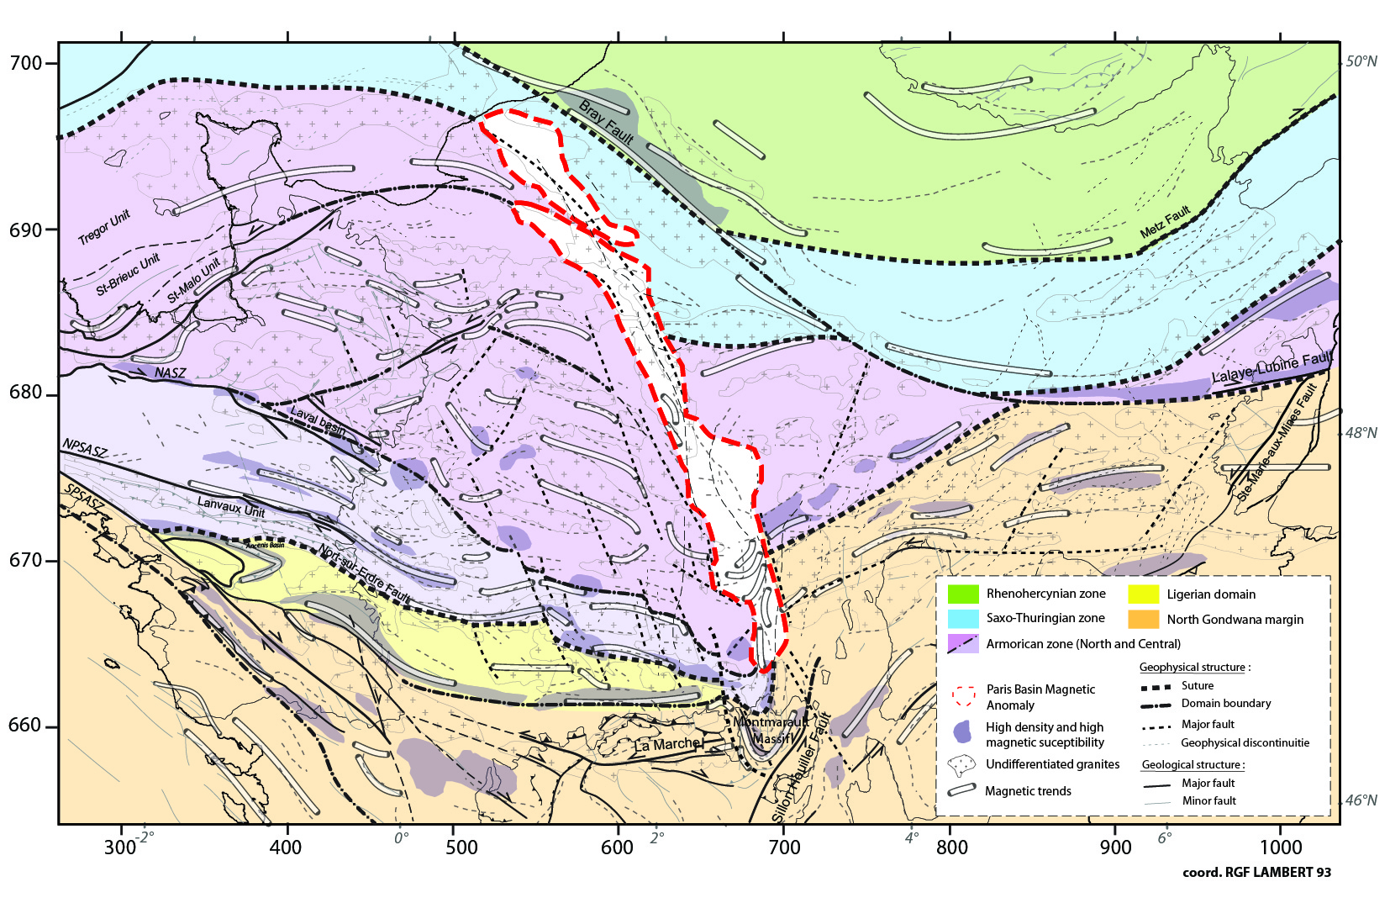
Tectonic map of the Pre-Mesozoic substratum of the Paris Basin obtained by (re)processing of aeromagnetic and gravimetric anomalies, and correlation with geological structures recognized in the surrounding Variscan massifs. NASZ: North Armorican shear zone; NBSASZ: North Branch of the South Armorican Shear Zone; SBSASZ: South Branch of the South Armorican Shear Zone. PBMA: Paris Basin magnetic anomaly.

